Assignment 1

Christo Steenekamp

27029085

Github username: ThisIsMineChristo

# Question 4

## 4.1

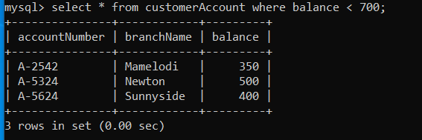

## 4.2

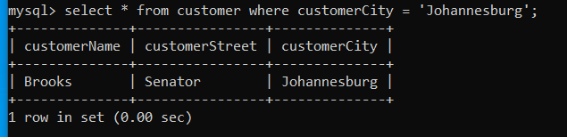  
4.3

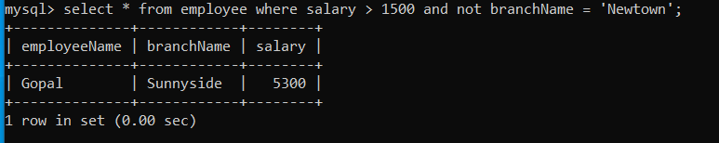

4.4

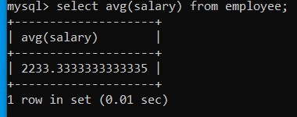

**NOTE:**  Average may vary due to foreign key referenced from bankBranch(branchName), thus

Austin is not a city that is present in table bankBranch

## 4.5

# 